System Requirements Statement (SRS)
Car-Pooling

Index | Content | Page no.
1 | Introduction | 3
2 | Functional Requirements | 4
3 | User Module | 5
4 | Driver Module | 8
5 | Passenger Module | 10
6 | Admin Module | 12
7 | User Case Diagram | 13

Introduction

This document explains the system requirements and scope for developing a car-pooling System.

Car-pooling System is divided into four main parts: User Module, Driver Module, Passenger module and Admin module.

Functional Requirements

The Account part of the Car-Pooling System has three modules which are divided into 24 processes described below.

No | BRS Requirement ID | Description
2.1 | User Module
2.1.1 | F1 | SignUp
2.1.2 | F2 | Login
2.1.3 | F3 | Password Management
2.1.4 | F4 | Update Profile
2.1.5 | F5 | History
2.1.6 | F6 | Support and Help
2.2 | Driver Module
2.2.1 | F7 | Ride Creation
2.2.1 | F8 | Edit Ride
2.2.1 | F9 | Cancel Ride
2.2.2 | F10 | View Passenger Booking
2.2.2 | F11 | Accept or Reject Booking Request
2.2.3 | F12 | ViewRatings and Feedback
2.2.3 | F13 | Give Rating and Feedback
2.2.3 | F14 | Trip History
2.3 Passenger Module
2.3.1 | F15 | Ride Booking and Management
2.3.2 | F16 | Cancel Ride Booking
2.3.4 | F18 | Booking Confirmation
2.3.5 | F19 | ViewRatings and Feedback
2.3.6 | F20 | Give Rating and Feedback
2.3.7 | F21 | Trip History
2.4 Admin Module
2.4.1 | F22 | User Management
2.4.2 | F23 | Ride Management
2.4.3 | F24 | Reporting and Analytics

- USER MODULE :

  - SIGN UP / USER REGISTRATION :
- Whenever a user enters for the first time, if the user is not registered so they can view a website to become a user he/she has to register through sign up.
  - SIGN UP SECTION :
- They have to enter the below details to successfully sign up.
1 Email
2. Password
3. Confirm Password
4. Full Name
5. Mobile
6. Address
7. Gender
8. Driving License no.
9. Aadhar Card no.
10. Photograph
- In the first page the user has to enter his email Id password and confirm password and OTP for sign up.
- After successfully adding email id password and confirm password , users move to the next part where more details have to be added. Those are Full Name ,Mobile ,Address ,Gender ,photo, Aadhar card & Driving License.
- In the above all the fields are mandatory except driving license(for passenger module DL is not compulsory).

  - VALIDATION :
- Email ID is verified using OTP while signing up.
- Passwords must contain one special character, one capital letter and one number.
- After successful registration of the user a user ID is generated.

- So whenever a user login user has to enter the same email Id and password.
- This all field details are passed to the database
3.4 LOG IN :
- In the login page the user has to enter Email Id and password.
- In Login Page Three buttons are there one button for Login, one button for forgot password and other for signup
- If user enter a valid details for login he will be successfully logged in Website, so user can publish or book a ride
- If the user presses the sign up button he will go to the sign up page.
- If a user clicks the forgot password he will go to specific forgot password Section

3.5 PASSWORD MANAGEMENT :
- This section's objective is to handle forgetting password change password.
- If the user selects the forget password, the user has to enter his email Id.
- Once user has entered email id successfully it get compared with database and Password is sent to user email ID
- If details entered by the user are wrong then a straight away error message is thrown below the login button.

3.6 UPDATE PROFILE :

- In update profile section the attributes which are entered during registration time
- Aadhar Card and driving license once entered cannot be changed.
- In update account password there is one more link to change the password
- In the change password section the user has to enter the old password, then new password and confirm the new password.
- If driving license details are entered at the time of a registration then the user can publish a ride as well as he can book a ride.
- If the user has not entered any driving license details at the time of a registration then he can only book a ride.
- If the user updates their profile and enters a Driving License then the user is eligible for publishing a ride.
3.7 TRIP HISTORY :
- Key Features of a Trip History
  - Ride History
  - Feedback and Ratings
  - Fare Price and Fare History

- Ride History : Display a list of past rides the user has either driven or joined as a passenger. pickup and drop location with date and time , Fare Amount.
- Feedback and Ratings : Allow users to view feedback received from passengers or drivers on past rides.

  - SUPPORT AND HELP:
- Key Features :
  - User Guides and Documentation
  - Issue Reporting and Feedback
  - Safety and Security Assistance

- User Guides and Documentation : Include step-by-step tutorials for new users on how to use the carpooling system. Provide guided walkthroughs on setting up a profile, scheduling rides, and managing bookings.
- Issue Reporting and Feedback : Allow users to report issues with an option to categorize (e.g. technical problem).

Driver Module

Ride Creation and Management

- Ride Creation :
  - The system shall allow drivers to create new rides by providing the following information:
    - Source location (address or coordinates)
    - Destination location (address or coordinates)
    - Departure Date and time of the ride
    - Vehicle Info
    - Number of available seats
    - Expected fare
    - Any specific preferences or restrictions (e.g., no smoking, pets allowed)

- Edit Ride :
  - The system shall allow drivers to edit information and modify details of their existing ride:
    - Departure date and time
    - Estimated fare
    - Specific preferences or restrictions
  - Edit Ride function only available till before journey date

- Cancel Ride :
  - Drivers shall be able to cancel an upcoming ride before the scheduled departure date.
  - The system shall notify all booked passengers about the cancellation.
  - Passenger Booking Management
- View Passenger Bookings
- Driver shall be able to view a list of passengers who have booked their ride, including:
  - Passengers name
  - Pickup and drop-off locations
  - Departure Date and time
  - Any special requests or preferences from passenger

  - Accept or Reject Booking Requests :
- Driver shall be able to review each booking request and decide to accept or reject it.
- Upon accepting a booking, the system shall notify the passenger.
- Upon rejecting a booking, the system shall notify the passenger.

Rating And Feedback For Driver

Receive Ratings and Feedback :

After completing a ride, the driver shall receive a rating from the passenger on a scale of 1 to 10.

- View Ratings and Feedback :
  - Drivers shall be able to view their overall rating and recent feedback from passengers.
  - The system shall provide a visual representation of the ratings (e.g., star rating).

- Give Rating and Feedback:
  - Driver shall be able to provide feedback and rating to the passenger's overall behavior during the ride.
  - Trip History
- Access to past ride details.
- Using certain Date filters

  - Support and Help
- Contact support via email.

- Passenger Module
- In a Car Pooling system the passenger is the person using the service to travel from one location to another.
- Passengers are also able to compare prices of different rides.

  - Ride Booking and Management

    - Ride Booking
- The system shall allow passengers to search for a ride by providing the following information.
  - Source location
  - Destination location
  - Departure Date and time of the ride
  - Driver details and vehicle information.
  - Number of available seats
  - Expected fare
- Before ride booking system ask passenger certain details
  - Pickup location(Address or co-ordinates)
  - Drop location(Address or co-ordinates)
  - Any special request or preferences for the driver.
    - Cancel Ride Booking
- Passengers shall be able to cancel a ride before the journey date.
- The system shall notify the driver about the cancellation of the ride.
    - Booking Confirmation
- Passengers receive a booking confirmation via the app, email, or SMS.
- Details include ride summary, pickup time, driver contact Information and final fare.
    - Rating And Feedback For Passenger
- Receive Ratings and Feedback :
  - After completing a ride, the passenger shall receive a rating from the rider on a scale of 1 to 10.
- View Ratings and Feedback :
  - Passengers shall be able to view their overall rating and recent feedback from the driver.
  - The system shall provide a visual representation of the ratings (e.g., star rating).

- Give Rating and Feedback:
  - Passengers shall be able to provide feedback and rating to the drivers overall behavior during the ride.
    - Trip History
- Access to past ride details.
- Using certain Date filters.

    - Support and Help
- Contact support via email.

6 Admin Module
- a Car Pooling system the admin monitors the system activity, track user behavior and analyzes the statistics to optimize platform experience..
- Admin is also able to ban or suspend user profiles to ensure platform security and compliance.
- if user continuously getting lower ratings more than 5 times then user will get suspended for 5 weeks, and get email for suspension
- After Resumption if a user still gets bad ratings the user will permanently ban from the website.
  - User Management

- Suspend or ban users.
- Verify user identities.
- manage user feedback and ratings.

  - Ride Management

- View and manage ride bookings.
- Track ride statistics, including ride duration, and ratings.

  - Reporting and Analytics

- Generate reports on user activity, including login history and ride frequency.
- View ride history, including ride details and user information.
- Analyze user feedback and ratings to improve platform quality.
- Generate reports on user ratings and feedback.

Use Case Diagram

User Module:
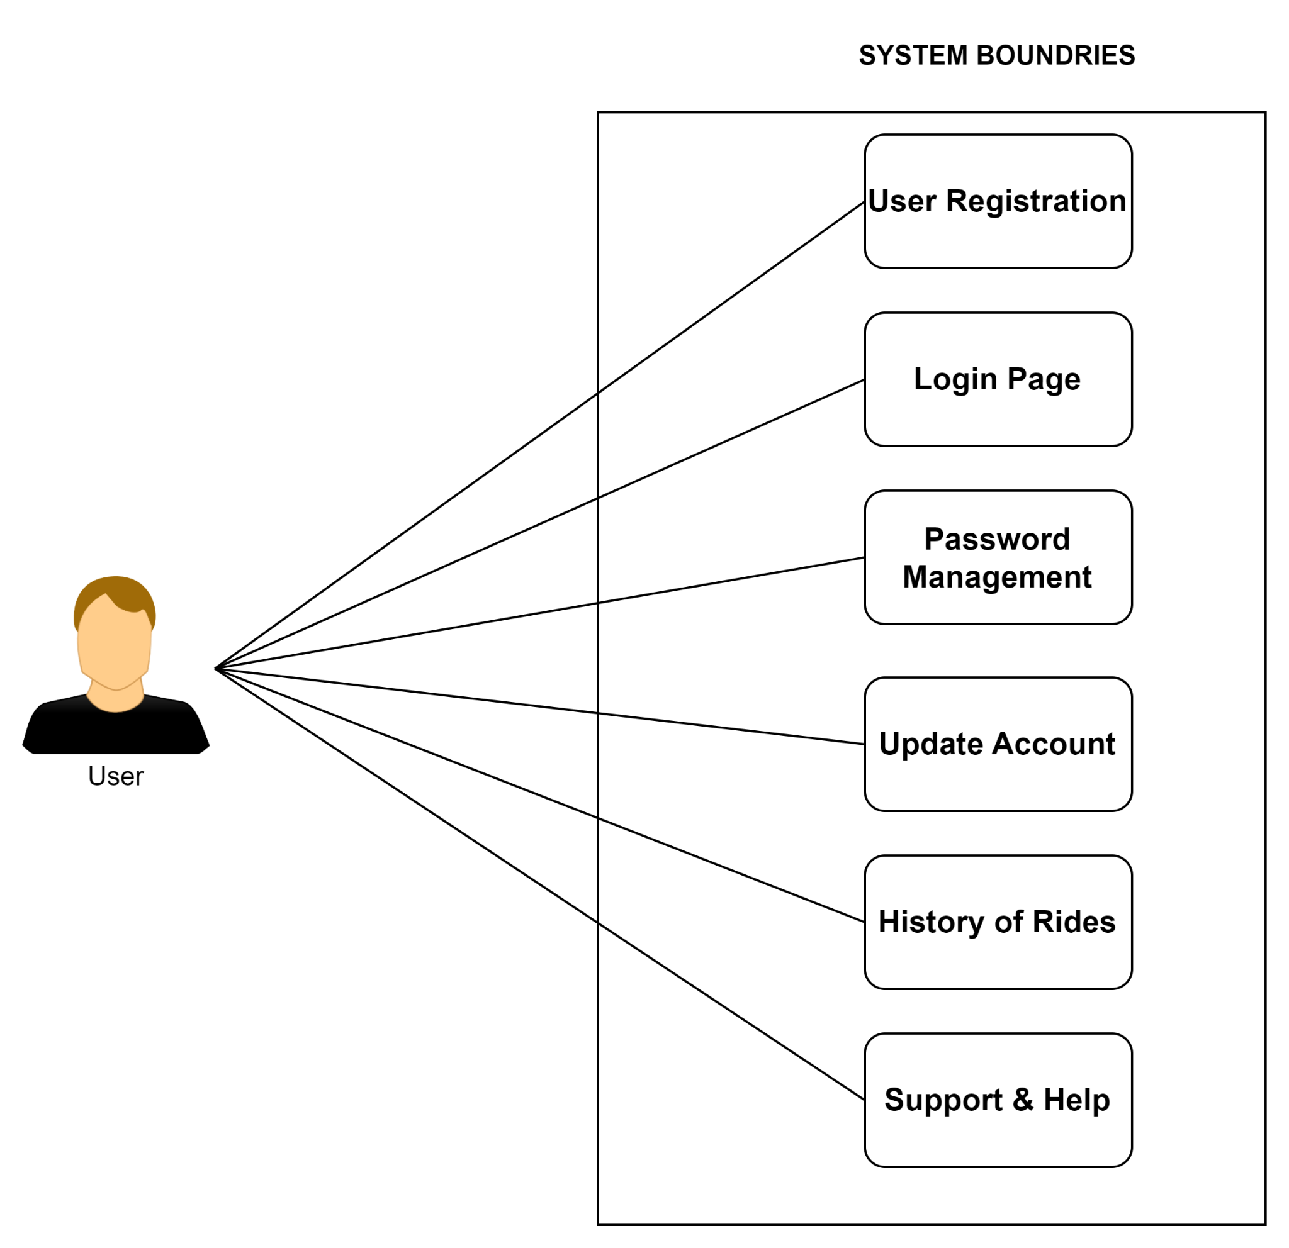

Fig 2.5.1 User Module Diagram

Driver Module:

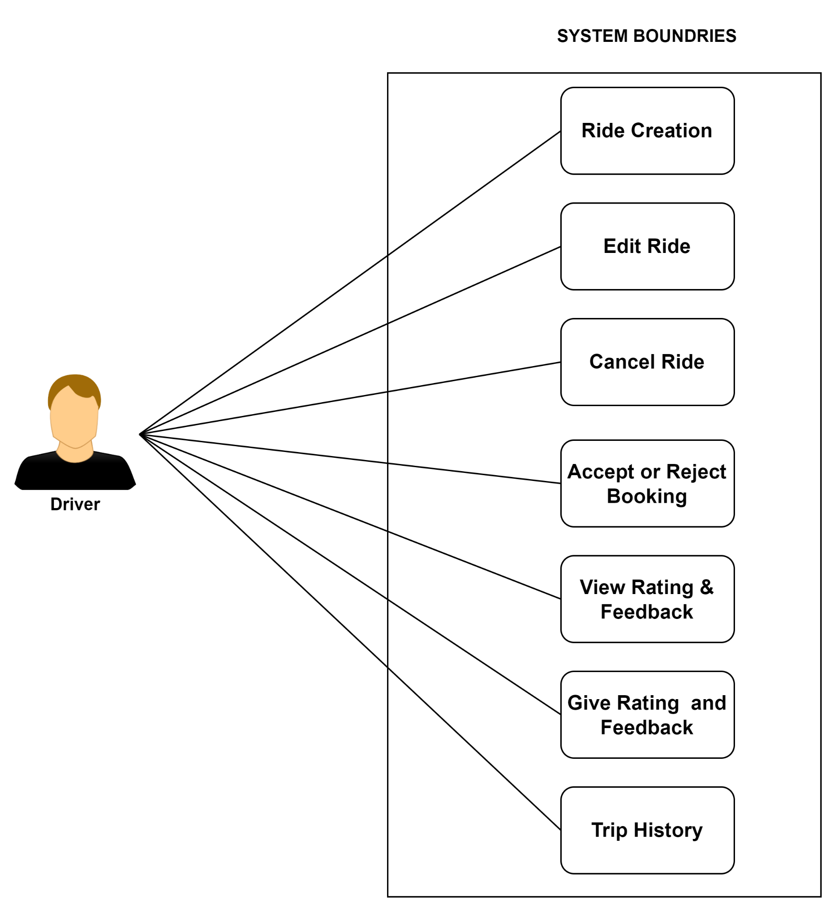

Fig 2.5.2 Driver Module Diagram

  - Passenger Module :
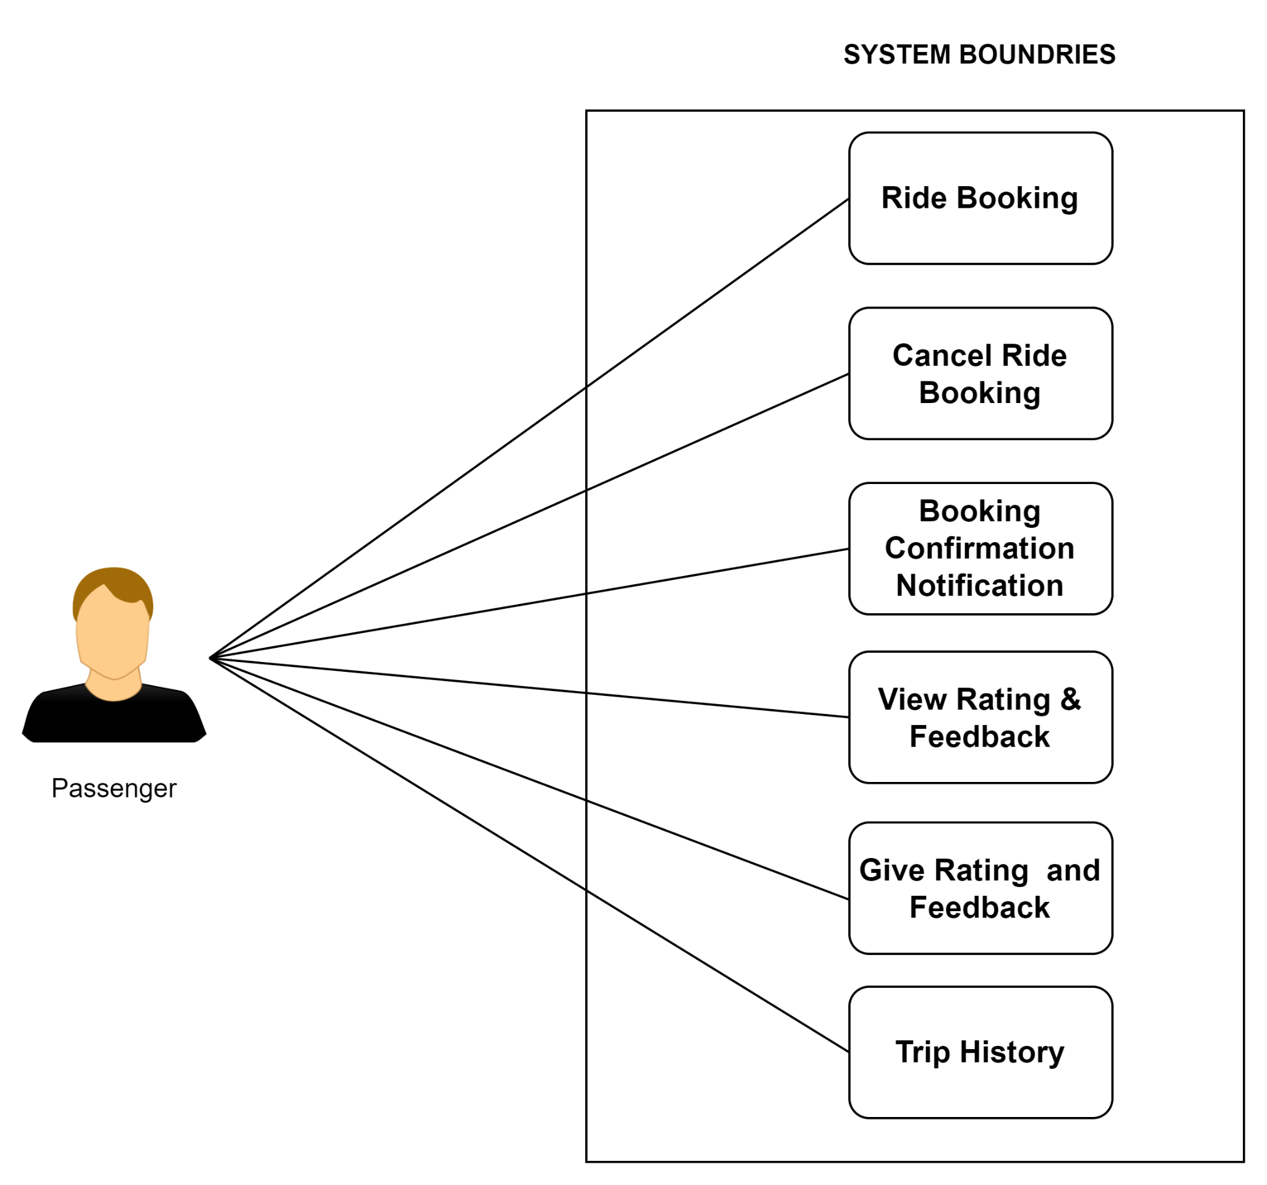

Fig 2.5.3 Passenger Module Diagram

  - Admin Module

